**Template Literals :**

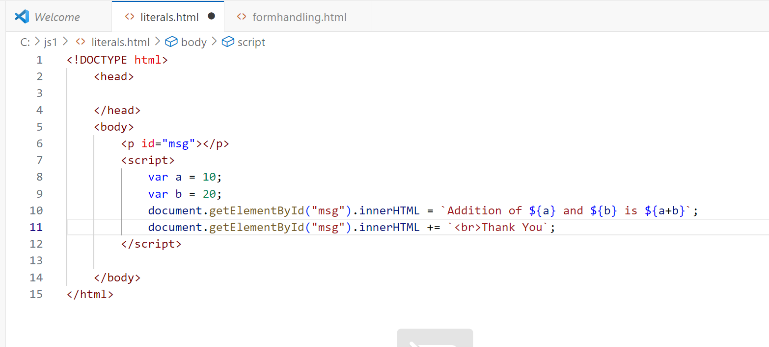

**Js Objects :**

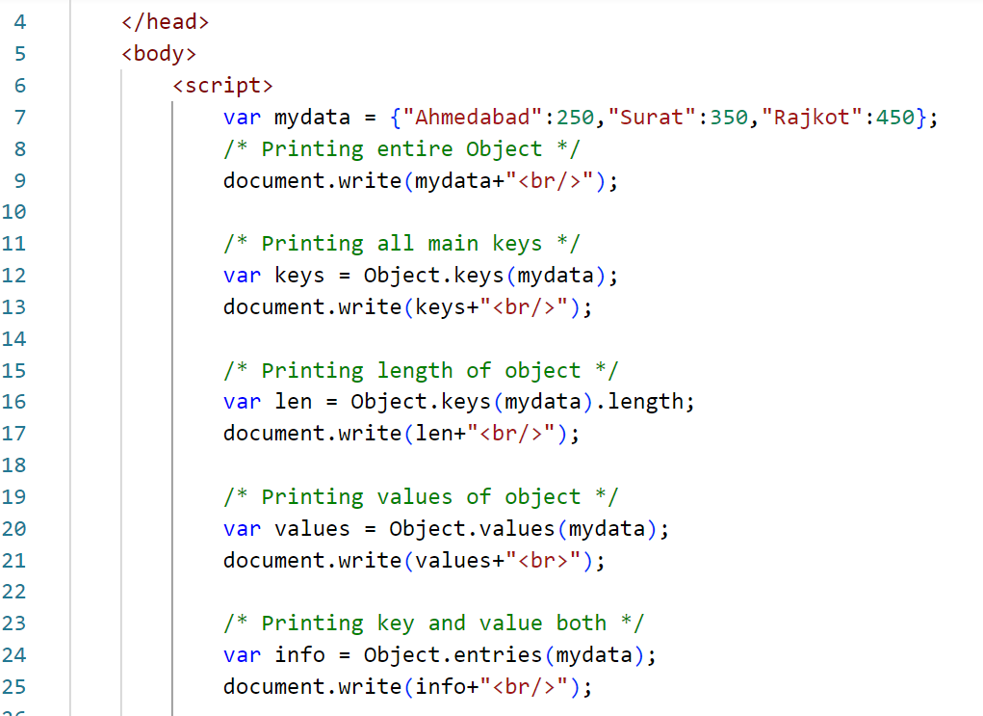

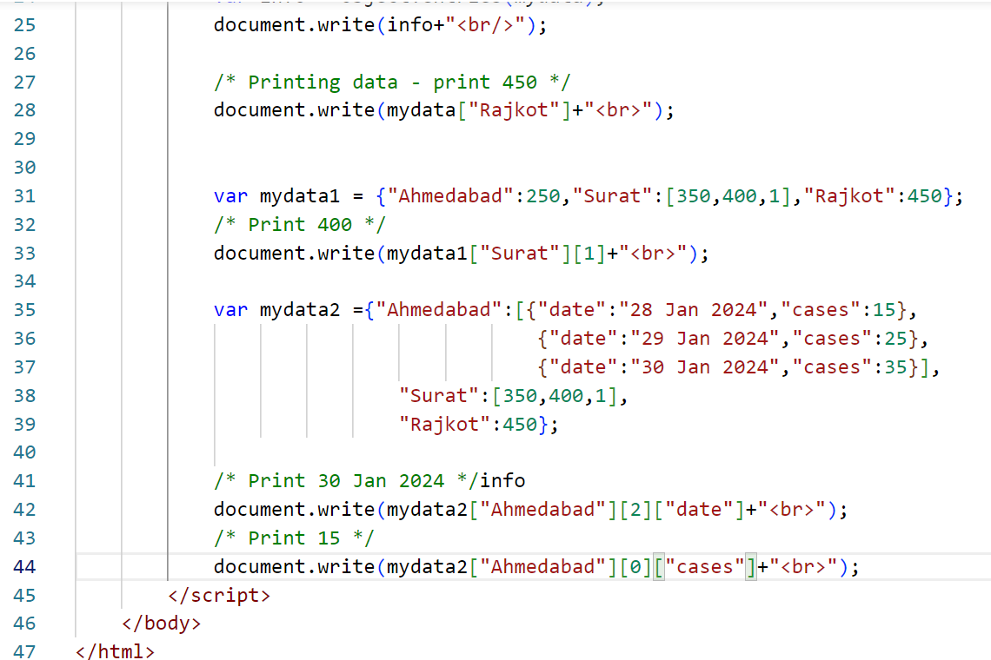

**EXERCISE 1 :**

mydata= {

"maharashtra":{"mumbai":{"city":"metro city","metro":"yes"}, "population":"20 cr"},

"gujarat": ["AHMEDABAD","SURAT","RAJKOT"],

"rajasthan":["AJMER","JAISALMER",{"capital":"jaipur"},["MEWAD","RJ","INR"]]

}

*Question 1 : print metro city*

*Question 2 : print jaipur*

*Question 3 : print Rajkot*

*Question 4 : print RJ*

**EXERCISE 2 :**

mydata= {"category":[{"A":"FIRST","package":{"data":"2lacs"}},

{"B":"Second","data":{"new":[100]}},{"C":"Third","Tests":[45,75,25]}]};

*Question 1 : print 2lacs*

*Question 2 : print 25*

*Question 3 : print 100*

**PRINTING JS OBJECT DATA TO A TABLE**

**var players = {**

**"virat":[25,15,7,12,65],**

**"rohit":[55,15,33,7,45],**

**"dhoni":[15,32,0,75,65],**

**"shikhar":[50,20,25,75,45],**

**"pant":[10,25,22,55,75],**

**"rahane":[15,25,55,45,0],**

**};**

SOLVE FOLLOWING QUESTIONS:

1. PRINT TOTAL NUMBER OF PLAYERS
2. PRINT TOTAL NUMBER OF MATCHES
3. PRINT NAME OF ALL PLAYERS
4. PRINT ALL DATA IN TABLE IN SUCH A WAY
   1. IF SCORE IS 0 THEN IT SHOULD BE DISPLAYED IN RED FONT 0
   2. IF SCORE 30 TO 49 PRINT SCORE IN GREEN FONT
   3. HIGHLIGHT ( MARK TAG ) SCORE WITH GREATER OR EQUAL TO 50

**EXPECTED OUTPUT :**

